DEVOPS MSE -1
NAME :- Apoorvi Anand
Uni Roll No. :- 202401100200075
Submission Evidence
Submit the following:
1.GitHub repository URL:-
https://github.com/apoorvi1/github-skills-challenge

2.Pull request URL used to validate the workflows:-
https://github.com/apoorvi1/github-skills-challenge/pulls

3.Screenshot showing the GitHub Actions workflows:-
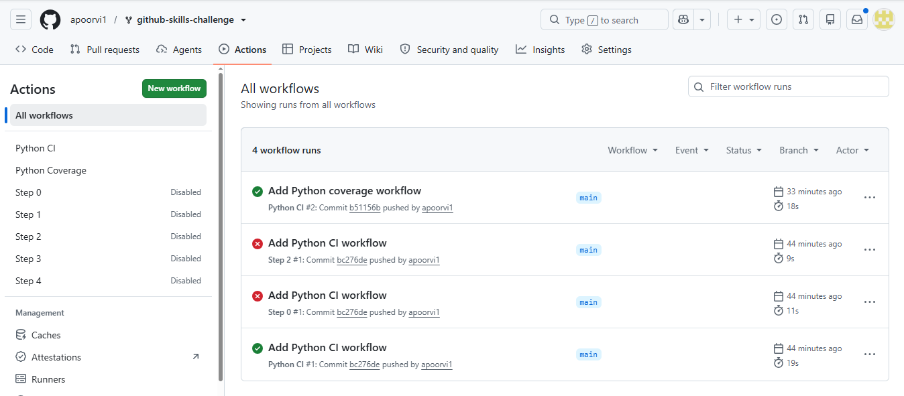

4.Screenshot showing a successful test workflow execution:-
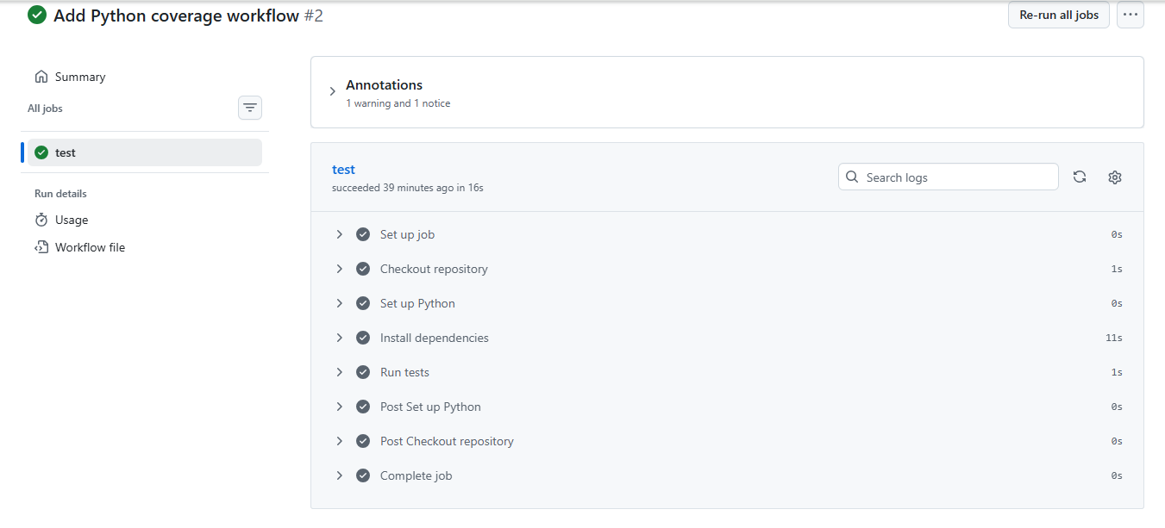
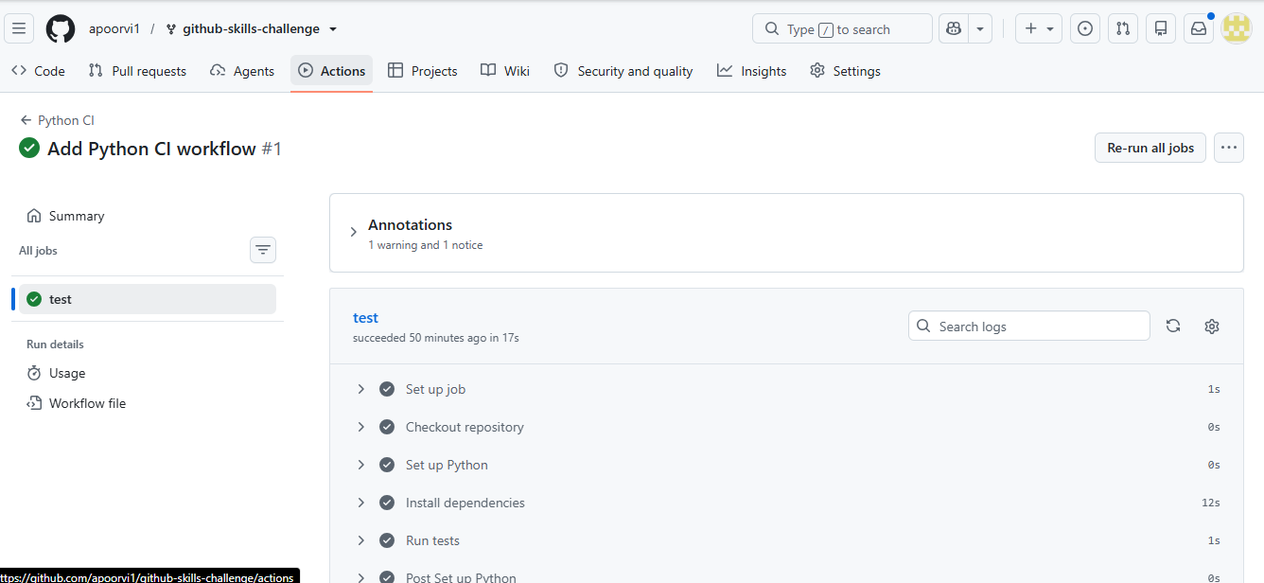

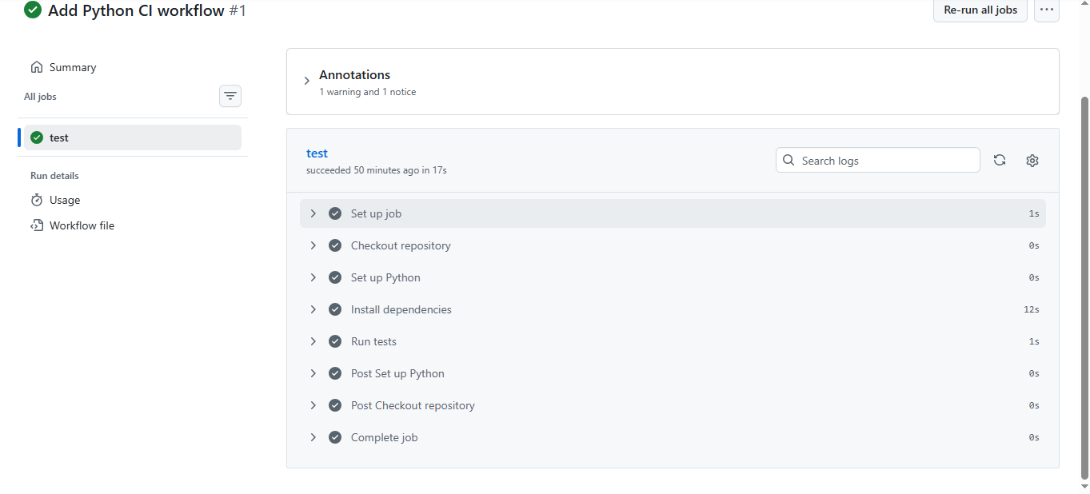

- Screenshot showing the coverage result/comment on the pull request:-
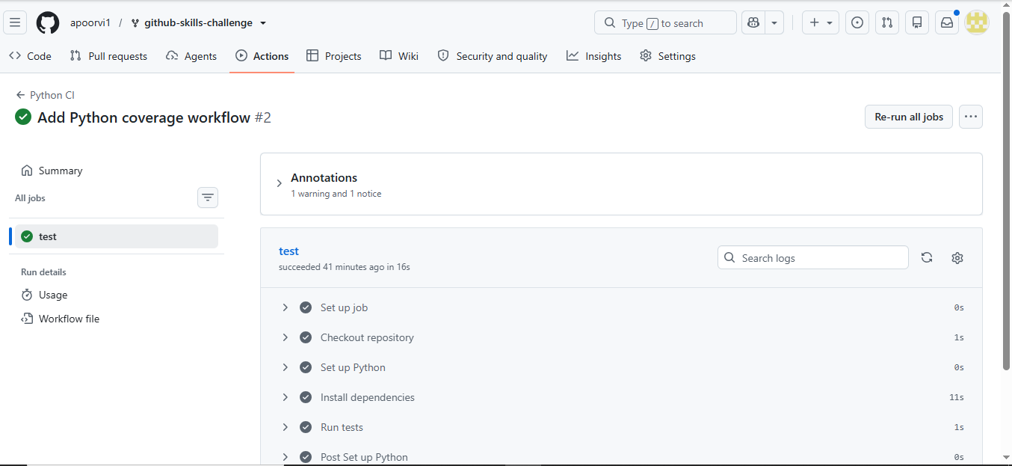
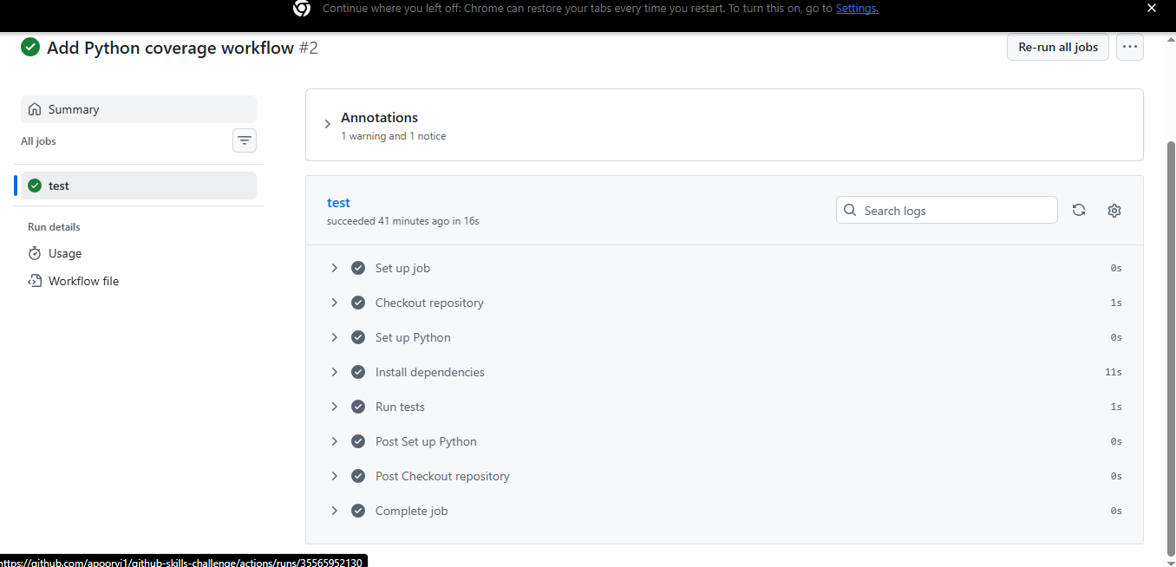

- Screenshot showing the final repository/workflow files
